Lesson 3 Assignment

Laura Bartlett

Source code:

##Lesson 3 Assignment##

amount=int(input("Enter the investment amount (greater than 0 but less than 50,000)"))

while amount <= 0 or amount > 50000:

    print("Invalid input, please try again.")

    amount=int(input("Enter the investment amount (greater than 0 but less than 50,000)"))

rate=int(input("Enter the interest rate (greater than 0 but less than 15)"))

while rate <= 0 or rate > 15:

    print("Invalid input, please try again.")

    rate=int(input("Enter the interest rate (greater than 0 but less than 15)"))

duration=int(input("Enter the duration of the investment in years (greater than 0)."))

while duration <= 0:

    print("Invalid input, please try again.")

    duration=int(input("Enter the duration of the investment in years (greater than 0)"))

months=12

for period in range (duration + 1):

        total = "%.2f" % (amount \* (pow((1 + rate / 100 / months), months \* period)))

        print(f'Year', period + 1, total)

print("Completed by Laura Bartlett")

Screenshot of Source code:

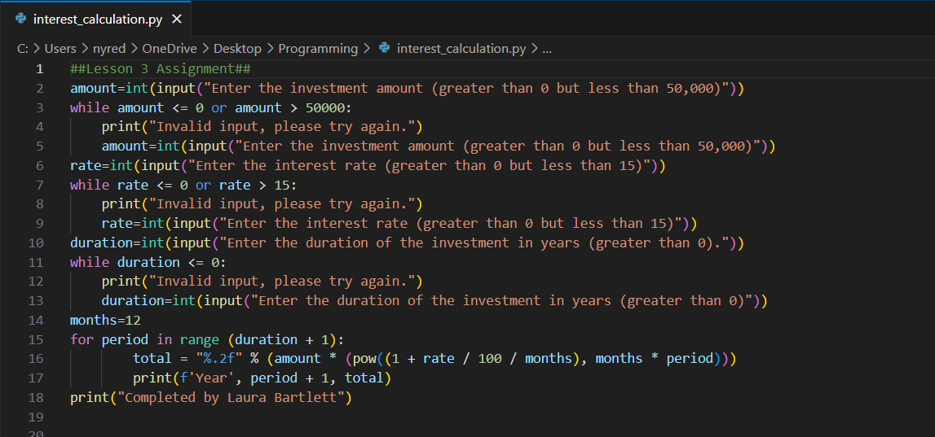

Here is what happened when I ran the program:

First, I tried entering an amount over $50,000 to make sure that it would say it was invalid, and it did.

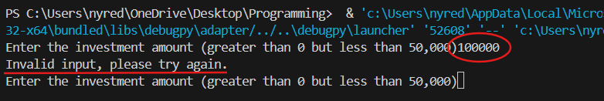

Then, I tried entering an interest rate of 0, and was told the input was invalid as expected.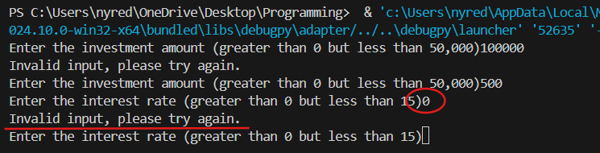

Then I tried entering a duration of 0, and it told me the input was invalid.

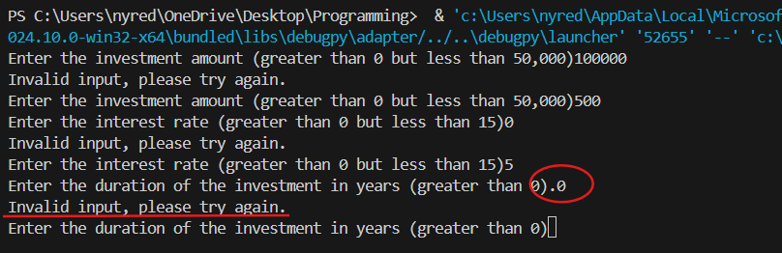

When I entered an investment amount of $500, an interest rate of 5% and a duration of 10 years, here is the output the program gave me.

